**Class and Object**

1. Write a program with the following structure  
   1.1 Class -> Calc  
   1.2 Method -> add  
   1.3 Method -> sub  
   1.4 Method -> mul  
   1.5 Method -> div  
   Receive two parameter for processing in each method and display the result.

class calc:

def add(a,b):

print(a+b)

def sub(a,b):

print(a-b)

def mul(a,b):

print(a*b)

def div(a,b):

print(a/b)

calc.add(2,4)

calc.sub(2,4)

calc.mul(2,4)

calc.div(2,4)

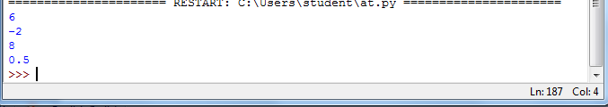

1. Write a program with the following structure  
   2.1 Class -> Calc  
   2.2 Constructor which will assign the value for 2 variable a and b  
   2.3 Method -> add  
   2.4 Method -> sub  
   2.5 Method -> mul  
   2.6 Method -> div  
   Consider the instance variable for processing in each method and display the result.

class calc:

def __init__(self,a,b):

self.a=a

self.b=b

def add(self):

print(self.a+self.b)

def sub(self):

print(self.a-self.b)

def mul(self):

print(self.a*self.b)

def div(self):

print(self.a/self.b)

ob=calc(2,4)

ob.add()

ob.sub()

ob.mul()

ob.div()

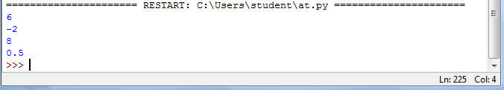

1. Write a program with the following structure  
   3.1 Class -> Calc  
   3.2 Two variable a,b should be declared as static  
   3.3 Static Method -> 'set' (which will assign the value for 2 variable a and b)  
   3.4 Static Method -> add  
   3.5 Static Method -> sub  
   3.6 Static Method -> mul  
   3.7 Static Method -> div  
   Consider the Static variable for processing in each method and display the result.   
   Call all the methods with out creating object for the class. (As all are static)

class calc:

a=0

b=0

@staticmethod

def set(a,b):

calc.a=a

calc.b=b

@staticmethod

def add():

print(calc.a+calc.b)

@staticmethod

def sub():

print(a-b)

@staticmethod

def mul():

print(a*b)

@staticmethod

def div():

print(a/b)

calc.set(15,25)

c = calc();

c.set(100,250)

calc.add()

c.add()

